# Linux Fat文件系统设计

## 开发环境

vim --version ─╯

VIM - Vi IMproved 8.2 (2019 Dec 12, compiled Apr 19 2022 21:42:29)

macOS version - arm64

Included patches: 1-4113

Compiled by root@apple.com

Normal version without GUI. Features included (+) or not (-):

Spacevim

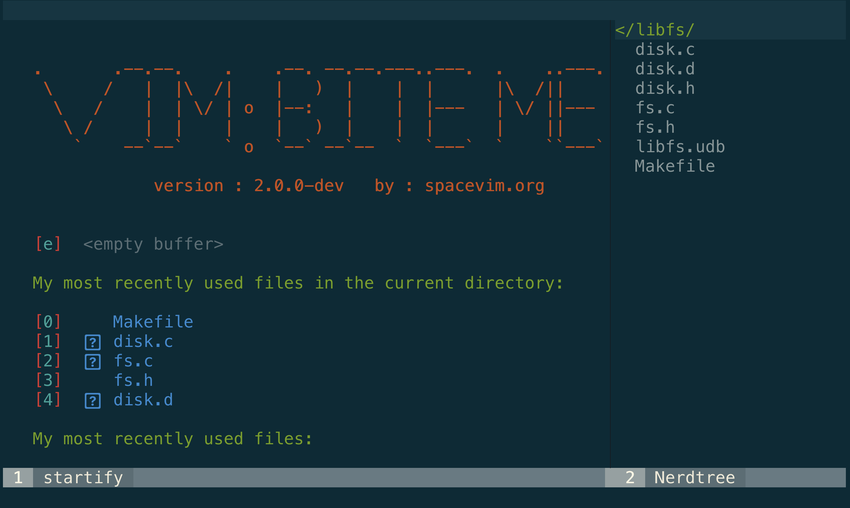

## 实验环境

Uname -a



ubuntu@VM-4-8-ubuntu:~$ cat /etc/issue

issue issue.net

ubuntu@VM-4-8-ubuntu:~$ cat /etc/issue

Ubuntu 20.04 LTS \n \l

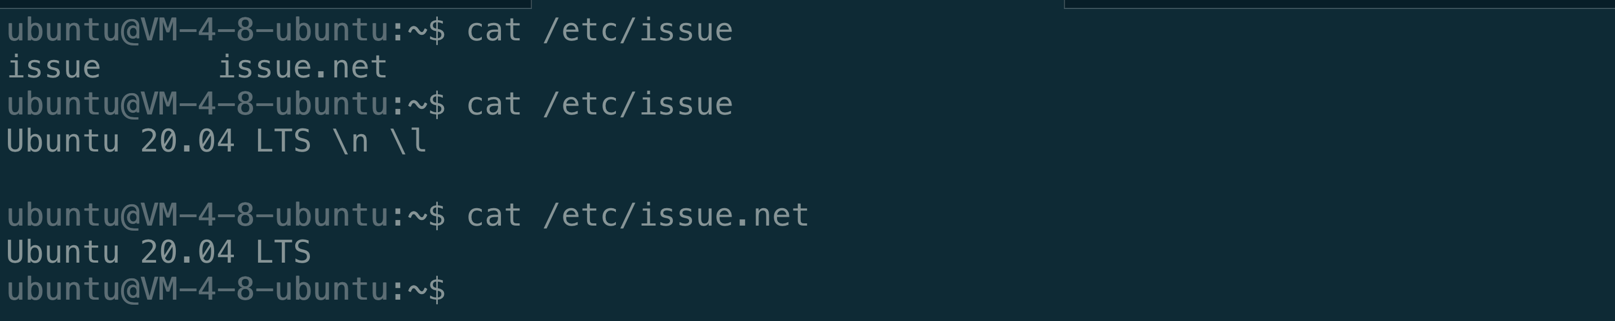

## 流程分析

### 文件系统数据结构

struct disk {

/* File descriptor */

int fd;

/* Block count */

size_t bcount;

};

需要使用__packed__指令进行内存对其，gcc专有

struct superblock {

uint8_t signature[8]; // ECS150FS

uint16_t total_blocks;

uint16_t root_dir_index;

uint16_t data_block_index;

uint16_t total_data_blocks;

uint8_t total_fat_blocks;

uint8_t padding[4079]; // to prevent malloc errors

}__attribute__((__packed__));

struct fat_block {

uint16_t entries[2048];

}__attribute__((__packed__));

struct root {

uint8_t filename[FS_FILENAME_LEN];

uint32_t filesize;

uint16_t first_db_num;

uint8_t padding[10]; // to prevent malloc issues

}__attribute__((__packed__));

struct fd {

int id;

int offset;

int root_entry;

}__attribute__((__packed__));

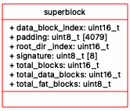 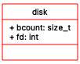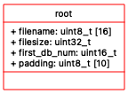

### 程序依赖情况如下

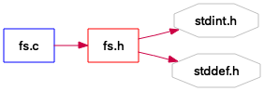

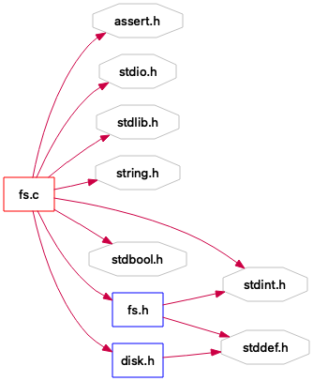

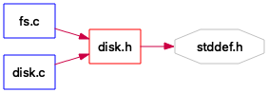

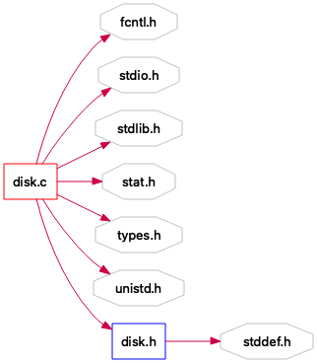

### 函数情况如下

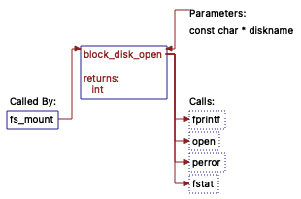

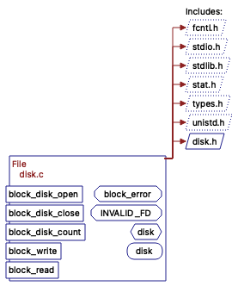

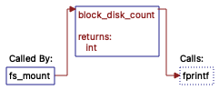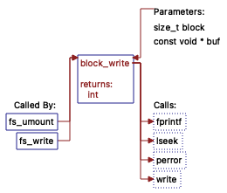

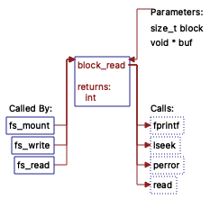



函数声明情况

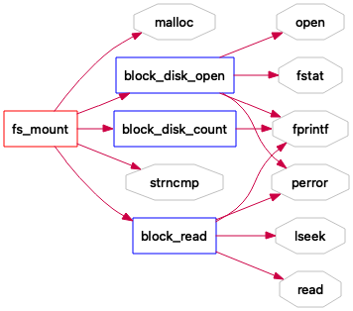

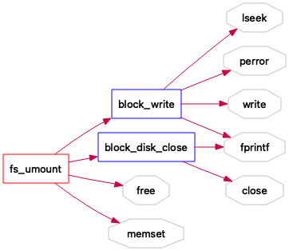

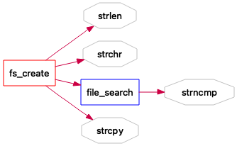

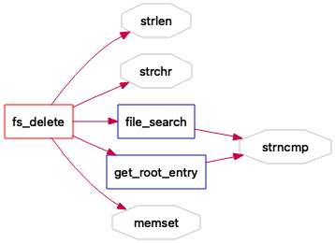

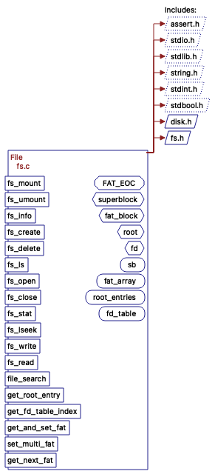

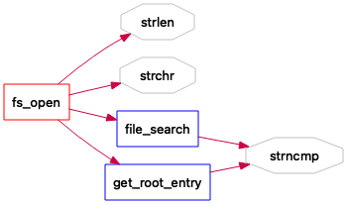

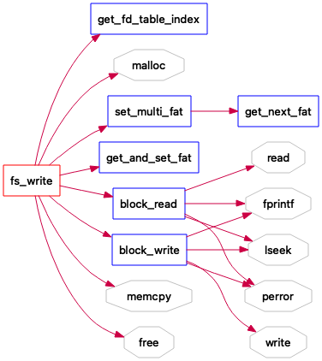

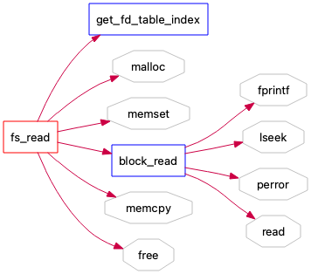

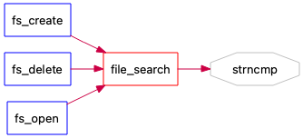

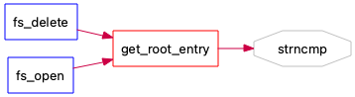

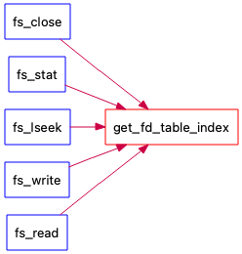

## 程序设计

Disk.c

#include <fcntl.h>

#include <stdio.h>

#include <stdlib.h>

#include <sys/stat.h>

#include <sys/types.h>

#include <unistd.h>

#include "disk.h"

#define block_error(fmt, ...) \

fprintf(stderr, "%s: "fmt"\n", __func__, ##__VA_ARGS__)

/* Invalid file descriptor */

#define INVALID_FD -1

/* Disk instance description */

struct disk {

/* File descriptor */

int fd;

/* Block count */

size_t bcount;

};

// 虚拟磁盘

static struct disk disk = { .fd = INVALID_FD };

int block_disk_open(const char *diskname)

{

int fd;

struct stat st;

if (!diskname) {

block_error("invalid file diskname");

return -1;

}

if (disk.fd != INVALID_FD) {

block_error("disk already open");

return -1;

}

if ((fd = open(diskname, O_RDWR, 0644)) < 0) {

perror("open");

return -1;

}

if (fstat(fd, &st)) {

perror("fstat");

return -1;

}

// 磁盘大小必须能被整除

if (st.st_size % BLOCK_SIZE != 0) {

block_error("size '%zu' is not multiple of '%d'",

st.st_size, BLOCK_SIZE);

return -1;

}

disk.fd = fd;

disk.bcount = st.st_size / BLOCK_SIZE;

return 0;

}

// 关闭磁盘

int block_disk_close(void)

{

if (disk.fd == INVALID_FD) {

block_error("no disk currently open");

return -1;

}

close(disk.fd);

disk.fd = INVALID_FD;

return 0;

}

int block_disk_count(void)

{

if (disk.fd == INVALID_FD) {

block_error("no disk currently open");

return -1;

}

return disk.bcount;

}

int block_write(size_t block, const void *buf)

{

// 磁盘还没被打开

if (disk.fd == INVALID_FD) {

block_error("no disk currently open");

return -1;

}

// 块数量超过磁盘大小

if (block >= disk.bcount) {

block_error("block index out of bounds (%zu/%zu)",

block, disk.bcount);

return -1;

}

// 一切正确，位移到相应的块位置

if (lseek(disk.fd, block * BLOCK_SIZE, SEEK_SET) < 0) {

perror("lseek");

return -1;

}

// 写入数据

if (write(disk.fd, buf, BLOCK_SIZE) < 0) {

perror("write");

return -1;

}

return 0;

}

// 读取数据块

int block_read(size_t block, void *buf)

{

if (disk.fd == INVALID_FD) {

block_error("no disk currently open");

return -1;

}

if (block >= disk.bcount) {

block_error("block index out of bounds (%zu/%zu)",

block, disk.bcount);

return -1;

}

// 位移到相应块

if (lseek(disk.fd, block * BLOCK_SIZE, SEEK_SET) < 0) {

perror("lseek");

return -1;

}

// 读取到buf

if (read(disk.fd, buf, BLOCK_SIZE) < 0) {

perror("read");

return -1;

}

return 0;

}

Disk.h

#ifndef _DISK_H

#define _DISK_H

#include <stddef.h>

// 块大小

#define BLOCK_SIZE 4096

int block_disk_open(const char *diskname);

int block_disk_close(void);

int block_disk_count(void);

int block_write(size_t block, const void *buf);

int block_read(size_t block, void *buf);

#endif /* _DISK_H */

Fs.c

#include <assert.h>

#include <stdio.h>

#include <stdlib.h>

#include <string.h>

#include <stdint.h>

#include <stdbool.h>

#include "disk.h"

#include "fs.h"

#define FAT_EOC 65535

int file_search(const char* filename);

int get_root_entry(const char* filename);

int get_fd_table_index(int fd);

size_t get_and_set_fat(size_t first_db_num);

int set_multi_fat (size_t *first_db_num, size_t offset_data_block);

int get_next_fat(int updated_i, int updated_j);

// 超级快数据

struct superblock {

uint8_t signature[8]; // ECS150FS

uint16_t total_blocks;

uint16_t root_dir_index;

uint16_t data_block_index;

uint16_t total_data_blocks;

uint8_t total_fat_blocks;

uint8_t padding[4079]; // 防止溢出

}__attribute__((__packed__));

struct fat_block {

uint16_t entries[2048];

}__attribute__((__packed__));

struct root {

uint8_t filename[FS_FILENAME_LEN];

uint32_t filesize;

uint16_t first_db_num;

uint8_t padding[10]; // to prevent malloc issues

}__attribute__((__packed__));

struct fd {

int id;

int offset;

int root_entry;

}__attribute__((__packed__));

static struct superblock* sb = NULL;

static struct fat_block* fat_array = NULL;

static struct root root_entries[FS_FILE_MAX_COUNT];// 128 for 1 root block

static struct fd fd_table[FS_OPEN_MAX_COUNT]; // maximum 32 fd's open at a time

int fs_mount(const char *diskname)

{

sb = malloc(sizeof(struct superblock));

if (block_disk_open(diskname) == -1) {

return -1;

}

if (block_read(0, sb) == -1) {

return -1;

}

// 签名

if (strncmp((char *)sb->signature, "ECS150FS", 8) != 0) {

return -1;

}

if (block_disk_count() != sb->total_blocks) {

return -1;

}

fat_array = malloc(sb->total_fat_blocks * sizeof(struct fat_block));

int total_fat_counter = (int)sb->total_fat_blocks;

size_t read_counter = 1;

while (total_fat_counter != 0) {

if (block_read(read_counter,

fat_array[read_counter-1].entries) == -1) {

return -1;

}

read_counter++;

--total_fat_counter;

}

if (fat_array[0].entries[0] != FAT_EOC) {

return -1;

}

if (block_read((size_t)sb->root_dir_index, root_entries) == -1) {

return -1;

}

for(int i = 0; i < FS_OPEN_MAX_COUNT; ++i) {

fd_table[i].id = -1; // set all to -1, b/c none has been opened

fd_table[i].offset = 0; //always init as 0

}

return 0;

}

int fs_umount(void)

{

if (!sb) {

return -1;

}

for (int i = 0; i < FS_OPEN_MAX_COUNT; ++i) {

if (fd_table[i].id != -1) {

return -1;

}

}

if (block_write(0, sb) == -1) {

return -1;

}

for (size_t i = 0; i < sb->total_fat_blocks; i++) {

if(block_write((i+1), fat_array[i].entries) == -1) {

return -1;

}

}

if (block_write(sb->root_dir_index, root_entries) == -1) {

return -1;

}

if (block_disk_close() == -1) {

return -1;

}

free(sb);

free(fat_array);

memset(root_entries, 0, BLOCK_SIZE);

memset(fd_table, 0, sizeof(struct fd)*FS_OPEN_MAX_COUNT);

sb = NULL;

fat_array = NULL;

return 0;

}

int fs_info(void)

{

if (!sb) {

return -1;

}

int fat_occupied_count = 0;

for (int i = 0; i < sb->total_fat_blocks; ++i) {

for (int j = 0; j < 2048; ++j) { // 2048 entries per FAT block

if (fat_array[i].entries[j] != 0) {

++fat_occupied_count;

}

}

}

int root_entry_free_count = 0;

for (int i = 0; i < FS_FILE_MAX_COUNT; ++i) {

if (root_entries[i].filename[0] == '\0') {

++root_entry_free_count;

}

}

printf("FS Info:\n");

printf("total_blk_count=%d\n", sb->total_blocks);

printf("fat_blk_count=%d\n", sb->total_fat_blocks);

printf("rdir_blk=%d\n", sb->root_dir_index);

printf("data_blk=%d\n", sb->data_block_index);

printf("data_blk_count=%d\n", sb->total_data_blocks);

printf("fat_free_ratio=%d/%d\n",

sb->total_data_blocks - fat_occupied_count, sb->total_data_blocks);

printf("rdir_free_ratio=%d/%d\n",

root_entry_free_count, FS_FILE_MAX_COUNT);

return 0;

}

int fs_create(const char *filename)

{

if (!sb) {

return -1;

}

if (strlen(filename) >= FS_FILENAME_LEN || strlen(filename) == 0) {

return -1;

}

if (!strchr(filename, '\0')) {

return -1;

}

if (file_search(filename) == 0) {

return -1;

}

int file_counter = 0; // temporary variable

for (int i = 0; i < FS_FILE_MAX_COUNT; ++i) {

if (root_entries[i].filename[0] != '\0') {

++file_counter;

}

}

if (file_counter == 128) {

return -1;

}

for (int i = 0; i < FS_FILE_MAX_COUNT; ++i) {

if (root_entries[i].filename[0] == '\0') {

strcpy((char *)root_entries[i].filename, filename);

root_entries[i].filesize = 0;

root_entries[i].first_db_num = FAT_EOC; // fat_EOC

break;

}

}

return 0;

}

int fs_delete(const char *filename)

{

if (!sb) {

return -1;

}

// Check if file name is invalid

if (strlen(filename) >= FS_FILENAME_LEN || strlen(filename) == 0) {

return -1;

}

// check if filename is null-terminated

if (!strchr(filename, '\0')) {

return -1;

}

// checks if filename is not found

if (file_search(filename) != 0) {

return -1;

}

int entry = get_root_entry(filename);

size_t first_db_num = root_entries[entry].first_db_num;

size_t db_index = first_db_num;

db_index += sb->root_dir_index;

++db_index; // skip over DB #0

size_t first_db_num_cpy = first_db_num; // for the while loop below

int fat_block_index = 0;

if (first_db_num_cpy >= 2048) {

while (first_db_num_cpy != 0 && first_db_num_cpy != FAT_EOC) {

++fat_block_index;

first_db_num_cpy /= 2048;

}

}

int root_index = get_root_entry(filename);

int amt_data_blocks = root_entries[root_index].filesize / BLOCK_SIZE + 1;

if (amt_data_blocks > 1) {

size_t next_entry = first_db_num;

size_t cur_entry = next_entry;

while (amt_data_blocks != 0) {

next_entry = fat_array[fat_block_index].entries[cur_entry];

fat_array[fat_block_index].entries[cur_entry] = 0;

cur_entry = next_entry;

amt_data_blocks--;

}

}

else {

if (fat_array[fat_block_index].entries[first_db_num] == FAT_EOC) {

fat_array[fat_block_index].entries[first_db_num] = 0;

}

}

// freeing the root entry

memset((char *)root_entries[entry].filename, 0, 16);

root_entries[entry].filename[0] = '\0';

root_entries[entry].first_db_num = 0;

root_entries[entry].filesize = 0;

return 0;

}

int fs_ls(void)

{

// sb being NULL implies nothing was mounted,

// since sb gets populated in fs_mount()

if (!sb) {

return -1;

}

printf("FS Ls:\n");

for (size_t i = 0; i < FS_FILE_MAX_COUNT; ++i) {

if (root_entries[i].filename[0] != '\0') {

printf("file: %s, size: %d, data_blk: %d\n",

root_entries[i].filename, root_entries[i].filesize,

root_entries[i].first_db_num);

}

}

return 0;

}

int fs_open(const char *filename) {

if (!sb) {

return -1;

}

// 检查文件名

if (strlen(filename) > FS_FILENAME_LEN || strlen(filename) == 0) {

return -1;

}

// 检查文件名末尾

if (!strchr(filename, '\0')) {

return -1;

}

// 查找文件名

if (file_search(filename) != 0) {

return -1;

}

// 文件未被打开

for(int i = 0; i < FS_OPEN_MAX_COUNT; ++i) {

if (fd_table[i].id == -1) {

fd_table[i].id = i;

fd_table[i].root_entry = get_root_entry(filename);

return fd_table[i].id;

}

}

return -1;

}

int fs_close(int fd)

{

if (!sb) {

return -1;

}

if (fd < 0) {

return -1;

}

int fd_index = get_fd_table_index(fd);

if (fd_index == -1) {

return -1; // 文件未被打开

}

fd_table[fd_index].id = -1;

return 0;

}

int fs_stat(int fd)

{

if (!sb) {

return -1;

}

if (fd < 0) {

return -1;

}

int fd_index = get_fd_table_index(fd);

if (fd_index == -1) {

return -1;

}

return root_entries[fd_table[fd_index].root_entry].filesize;

}

int fs_lseek(int fd, size_t offset)

{

if (!sb) {

return -1;

}

if (fd < 0) {

return -1;

}

// 文件描述符不存在

int fd_index = get_fd_table_index(fd);

if(fd_index == -1) {

return -1;

}

// 偏移量超出了文件大小

if(offset > root_entries[fd_table[fd_index].root_entry].filesize) {

return -1;

}

fd_table[fd_index].offset = (int)offset;

return 0;

}

int fs_write(int fd, void *buf, size_t count)

{

if (!sb) {

return -1;

}

// 文件描述符不存在

int fd_index = get_fd_table_index(fd);

if (fd_index == -1) {

return -1;

}

if (count == 0) {

return 0;

}

root_entries[fd_table[fd_index].root_entry].filesize += (uint32_t)count;

size_t amnt_data_blocks = (count / BLOCK_SIZE) + 1; // due to truncation

size_t buf_offset = 0;

size_t multi_count = count;

void *bounce_buf = malloc(BLOCK_SIZE);

size_t first_db_num =

root_entries[fd_table[fd_index].root_entry].first_db_num;

size_t fd_offset = (size_t)fd_table[fd_index].offset;

uint32_t filesize = root_entries[fd_table[fd_index].root_entry].filesize;

size_t first_db_num_cpy = first_db_num; // for the while loop below

int fat_block_index = 0;

if (first_db_num_cpy >= 2048 && first_db_num_cpy != FAT_EOC) {

while (first_db_num_cpy != 0) {

++fat_block_index;

first_db_num_cpy /= 2048;

}

}

size_t block_offset = fd_offset/BLOCK_SIZE;

size_t byte_offset = fd_offset - (block_offset*BLOCK_SIZE);

size_t offset_data_block = amnt_data_blocks - block_offset;

size_t offset_db_index = block_offset;

// array that holds where fat entries are.

uint16_t fat_location[2048 * sb->total_fat_blocks];

size_t free_fat = 0;

if (amnt_data_blocks > 1) {

if (set_multi_fat(&first_db_num, offset_data_block) == -1) {

return 0; // no more free fat entries to write to

}

root_entries[fd_table[fd_index].root_entry].first_db_num

= (uint16_t)first_db_num;

fat_location[0] = (uint16_t) first_db_num;

}

else {

free_fat = get_and_set_fat(first_db_num);

fat_location[0] = (uint16_t) free_fat;

}

for(int i = 1; i < amnt_data_blocks; i++){

fat_location[i] = fat_array[fat_block_index].entries[fat_location[i-1]];

}

if (amnt_data_blocks == 1 && first_db_num == FAT_EOC) {

if (free_fat == 0) {

return 0; // FAT满

}

size_t db_index = free_fat + sb->root_dir_index;

++db_index; // skip over DB #0

// 更新数据块

root_entries[fd_table[fd_index].root_entry].first_db_num

= (uint16_t) free_fat;

block_write(db_index, buf);

}

else if (count + fd_offset <= filesize) {

while (offset_data_block != 0) {

if(count <= BLOCK_SIZE - byte_offset){

if (block_read(fat_location[offset_db_index]

+ sb->root_dir_index + 1,

bounce_buf) == -1) {

return -1;

}

memcpy(bounce_buf + byte_offset, buf,

BLOCK_SIZE - byte_offset);

block_write(fat_location[offset_db_index]

+ sb->root_dir_index + 1, bounce_buf);

fd_table[fd_index].offset += count;

free(bounce_buf);

return (int)count;

}

else {

if(byte_offset > 0) {

if (block_read(fat_location[offset_db_index]

+ sb->root_dir_index + 1,

bounce_buf) == -1) {

return -1;

}

memcpy(bounce_buf + byte_offset, buf,

BLOCK_SIZE - byte_offset);

block_write(fat_location[offset_db_index]

+ sb->root_dir_index + 1, bounce_buf);

buf_offset = buf_offset + (BLOCK_SIZE - byte_offset);

multi_count = multi_count - (BLOCK_SIZE - byte_offset);

offset_db_index++;

byte_offset = 0; //we'll never use this again

// if multi_count 0, we just return.

if (multi_count == 0) {

fd_table[fd_index].offset += multi_count;

free(bounce_buf);

return (int)multi_count;

}

}

else if (multi_count > BLOCK_SIZE) {

memcpy(bounce_buf, buf+buf_offset, BLOCK_SIZE);

block_write(fat_location[offset_db_index]

+ sb->root_dir_index + 1, bounce_buf);

buf_offset = buf_offset + BLOCK_SIZE;

multi_count = multi_count - BLOCK_SIZE;

offset_db_index++;

}

else {

if (block_read(fat_location[offset_db_index]

+ sb->root_dir_index + 1,

bounce_buf) == -1) {

return -1;

}

memcpy(bounce_buf, buf+buf_offset, multi_count);

block_write(fat_location[offset_db_index]

+ sb->root_dir_index + 1, bounce_buf);

fd_table[fd_index].offset += count;

free(bounce_buf);

return (int) count;

}

}

offset_data_block--;

}

}

fd_table[fd_index].offset += count;

return (int)count;

}

int fs_read(int fd, void *buf, size_t count)

{

if (!sb) {

return -1;

}

// invalid fd check

if (fd < 0) {

return -1;

}

// if the fd index doesn't exist, return -1

int fd_index = get_fd_table_index(fd);

if (fd_index == -1) {

return -1;

}

// array that holds where fat blocks are.

uint16_t fat_location[2048];

size_t fd_offset = (size_t)fd_table[fd_index].offset;

uint32_t filesize = root_entries[fd_table[fd_index].root_entry].filesize;

size_t amnt_data_blocks = (filesize/BLOCK_SIZE) + 1;

void *bounce_buf = malloc(BLOCK_SIZE); //used to hold a temp data block.

memset(bounce_buf, 0, BLOCK_SIZE);

uint32_t bytes_in_file = filesize;

size_t db_index

= root_entries[fd_table[fd_index].root_entry].first_db_num;

++db_index; // because db counts up from 0

db_index = db_index + sb->root_dir_index;

size_t first_db_num

= root_entries[fd_table[fd_index].root_entry].first_db_num;

size_t first_db_num_cpy = first_db_num; // for the while loop below

int fat_block_index = 0; //get which FAT block DB is located in

if (first_db_num_cpy >= 2048) {

while (first_db_num_cpy != 0) {

++fat_block_index;

first_db_num_cpy /= 2048;

}

}

fat_location[0] = (uint16_t)first_db_num;

for(int i = 1; i < amnt_data_blocks; i++){

// we get the index of what the current one is "pointing" to

fat_location[i] = fat_array[fat_block_index].entries[fat_location[i-1]];

}

size_t buf_offset = 0;

size_t multi_count = count;

if (filesize == fd_offset) {

return 0;

}

size_t block_offset = fd_offset/BLOCK_SIZE;

size_t byte_offset = fd_offset - (block_offset*BLOCK_SIZE);

size_t offset_data_block = amnt_data_blocks - block_offset;

size_t offset_db_index = block_offset;

if (fd_offset != 0) {

bytes_in_file = bytes_in_file - (uint32_t)fd_offset;

while (offset_data_block != 0) {

if (buf_offset == count) {

break;

}

if (block_read(fat_location[offset_db_index]

+ sb->root_dir_index + 1,

bounce_buf) == -1) {

return -1;

}

if (count <= BLOCK_SIZE - byte_offset) {

if (bytes_in_file > count) {

memcpy(buf + buf_offset,

bounce_buf + byte_offset,multi_count);

fd_table[fd_index].offset += count;

free(bounce_buf);

return (int)count;

}

else {

memcpy(buf, bounce_buf + byte_offset, bytes_in_file);

fd_table[fd_index].offset += bytes_in_file;

free(bounce_buf);

return (int)bytes_in_file;

}

}

else {

if (byte_offset > 0) { //should only run this fxn at most ONCE.

memcpy(buf, bounce_buf + byte_offset,

(BLOCK_SIZE- byte_offset));

buf_offset = buf_offset + (BLOCK_SIZE - byte_offset);

multi_count = multi_count - (BLOCK_SIZE - byte_offset);

offset_db_index++;

byte_offset = 0;

if (multi_count == 0) {

fd_table[fd_index].offset += multi_count;

free(bounce_buf);

return (int)multi_count;

}

}

// so if multi_count is still greater than BLOCK_SIZE,

// we just memcpy the whole block into buf.

else if(multi_count > BLOCK_SIZE) {

memcpy(buf + buf_offset, bounce_buf, BLOCK_SIZE);

buf_offset = buf_offset + BLOCK_SIZE;

multi_count = multi_count - BLOCK_SIZE;

offset_db_index++;

}

// multi_count less than BLOCK_SIZE

// we read what's left of the block.

else {

memcpy(buf + buf_offset, bounce_buf, multi_count);

fd_table[fd_index].offset += count;

free(bounce_buf);

return (int)count;

}

}

offset_data_block--;

} // end of while loop

if (fd_offset + count > filesize) {

fd_table[fd_index].offset += bytes_in_file;

free(bounce_buf);

return (int)bytes_in_file;

}

else {

fd_table[fd_index].offset += count;

free(bounce_buf);

return (int)count;

}

} // end of if

int iterator = 0; //used for iterating thru the fat_location

while (amnt_data_blocks != 0) {

if (buf_offset == count) {

break;

}

if (block_read((fat_location[iterator] + sb->root_dir_index + 1),

bounce_buf) == -1) {

free(bounce_buf);

return -1;

}

// if count < or = BLOCK_SIZE, we just read in everything to buf.

if (count <= BLOCK_SIZE) {

if (count > bytes_in_file) {

// here is if count > file size.

memcpy(buf, bounce_buf, bytes_in_file);

fd_table[fd_index].offset += bytes_in_file;

free(bounce_buf);

return (int) bytes_in_file;

}

else {

memcpy(buf, bounce_buf, count);

//we modify the offset before returning.

fd_table[fd_index].offset += count;

free(bounce_buf);

return (int)count;

}

}

else {

if (multi_count > BLOCK_SIZE) {

if (multi_count > bytes_in_file

&& bytes_in_file < BLOCK_SIZE) {

// here, we've read the maximum amount of blocks

// we then read what we can of the last block,

// and then finally return.

memcpy(buf+buf_offset, bounce_buf, bytes_in_file);

buf_offset = buf_offset + bytes_in_file;

fd_table[fd_index].offset += filesize;

free(bounce_buf);

return (int)filesize;

}

else {

memcpy(buf+buf_offset, bounce_buf, BLOCK_SIZE);

buf_offset = buf_offset + BLOCK_SIZE;

multi_count = multi_count - BLOCK_SIZE;

bytes_in_file = bytes_in_file - BLOCK_SIZE;

db_index++;

}

}

else {

// There are basically two scenarios here.

// if multi count is the limiter,

// or if filesize is the limiter.

if (multi_count < bytes_in_file) {

memcpy(buf+buf_offset, bounce_buf, multi_count);

buf_offset = buf_offset + multi_count;

db_index++;

}

else if (bytes_in_file <= multi_count) {

memcpy(buf+buf_offset, bounce_buf, bytes_in_file);

fd_table[fd_index].offset += filesize;

free(bounce_buf);

return (int)filesize;

}

}

}

--amnt_data_blocks;

iterator++;

} // end of while loop

// we modify the offset before returning.

fd_table[fd_index].offset += count;

free(bounce_buf);

return (int)count;

}

/* HELPER FUNCTIONS */

// Find a file named filename that exists inside the root entries.

// Return: -1 if filename was not found in the root entries.

// Otherwise return 0 to indicate file was found.

int file_search(const char* filename) {

for (int i = 0; i < FS_FILE_MAX_COUNT; ++i) {

if (strncmp( (char*)root_entries[i].filename,

filename, FS_FILENAME_LEN ) == 0) {

return 0; // found a match

}

}

return -1; // fail state: could not find file

}

// Find a file named @filename that exists inside the root entries.

// Return: -1 if @filename was not found in the root entries.

// Otherwise return the root entry index of where @filename

// was located in.

int get_root_entry(const char* filename) {

for (int i = 0; i < FS_FILE_MAX_COUNT; ++i) {

if (strncmp( (char*)root_entries[i].filename,

filename, FS_FILENAME_LEN ) == 0) {

return i; // found a match

}

}

return -1; // fail state: could not find file

}

// Find a file descriptor named @fd that exists inside

// the fd table array.

// Return: -1 if @fd was not found in the fd table.

// Otherwise return the index of where @fd was

// found in the fd table.

int get_fd_table_index(int fd) {

for (int i = 0; i < FS_FILE_MAX_COUNT; ++i) {

if (fd_table[i].id == fd) {

return i; // found index

}

}

return -1; // fail state: could not find opened fd

}

// sets the FAT entry for a file that is only 1 data block big.

// returns 0 if it reaches the complete end of the double for loops,

// meaning no more free fat entries available.

size_t get_and_set_fat(size_t first_db_num) {

for (int i = 0; i < sb->total_fat_blocks; ++i) {

for (int j = 0; j < 2048; ++j) { // 2048 entries per FAT block

if (first_db_num != FAT_EOC

&& fat_array[i].entries[first_db_num] == FAT_EOC) {

return first_db_num;

}

if (fat_array[i].entries[j] == first_db_num

&& first_db_num != FAT_EOC) {

return first_db_num;

}

if (fat_array[i].entries[j] == 0) {

// assign the file less than 4096 bytes

// to a singular, proper FAT entry, and set that

// to 0xFFFF.

fat_array[i].entries[j] = FAT_EOC;

return (size_t)j;

}

} // end of j loop

} // end of i loop

return 0; // no free fat_entries available

// => no free data blocks available.

}

// if the file has n data blocks associated,

// we use this function to assign n FAT entries

int set_multi_fat (size_t *first_db_num, size_t offset_data_block) {

int free_entry_check = 0;

for (int i = 0; i < sb->total_fat_blocks; ++i) {

if (offset_data_block == 0) {

break;

}

for (int j = 0; j < 2048; ++j) {

if (fat_array[i].entries[j] == 0) {

// case where we have contiguous free FAT entries

if (fat_array[i].entries[j + 1] == 0) {

fat_array[i].entries[j] = (uint16_t) (j+1);

// means first_db_num hasn't been set yet

if (*first_db_num == FAT_EOC) {

// only enters here once

*first_db_num = (size_t)j;

}

offset_data_block--;

}

else {

// non-contiguous case

// need some helper function to iterate from

// where we are now until it finds the next

// free fat entry. Then store this in free_entry_check.

free_entry_check = get_next_fat(i, j+1);

if (free_entry_check == -1) {

return -1; // no more free entries

}

fat_array[i].entries[j] = (uint16_t)free_entry_check;

// means first_db_num hasn't been set yet

if (*first_db_num == FAT_EOC) {

// only enters here once

*first_db_num = (size_t)j;

}

// update j so we don't iterate through unnecessary

// entries (any entry before get_next_fat() )

j = fat_array[i].entries[j] - 1;

--offset_data_block;

}

}

// the last entry should be set to 0xFFFF

if (offset_data_block == 0) {

fat_array[i].entries[j] = FAT_EOC;

break;

}

} // j loop end

} // i loop end

return 0; // success condition

}

// finds the next free fat entry. The first

// one the function finds, it returns.

int get_next_fat(int updated_i, int updated_j) {

for (int i = updated_i; i < sb->total_fat_blocks; ++i) {

for (int j = updated_j; j < 2048; ++j) {

if (fat_array[i].entries[j] == 0) {

return (uint16_t)j;

}

}

}

return -1; // no free fat_entries available

// => no free data blocks available.

}

Fs.h

#ifndef _FS_H

#define _FS_H

#include <stdint.h>

#include <stddef.h>

/** Maximum filename length (including the NULL character) */

#define FS_FILENAME_LEN 16

/** Maximum number of files in the root directory */

#define FS_FILE_MAX_COUNT 128

/** Maximum number of open files */

#define FS_OPEN_MAX_COUNT 32

int fs_mount(const char *diskname);

int fs_umount(void);

int fs_info(void);

int fs_create(const char *filename);

int fs_delete(const char *filename);

int fs_ls(void);

int fs_open(const char *filename);

int fs_close(int fd);

int fs_stat(int fd);

int fs_lseek(int fd, size_t offset);

int fs_write(int fd, void *buf, size_t count);

int fs_read(int fd, void *buf, size_t count);

#endif /* _FS_H */

## 运行截图

### make编译

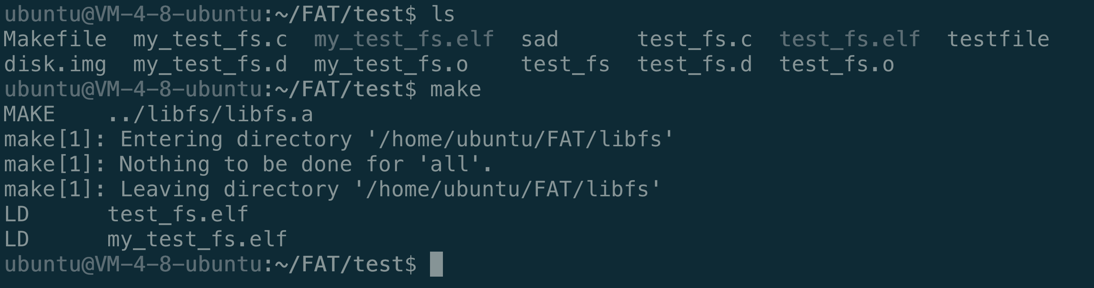

### 创建img镜像



### 查看镜像信息

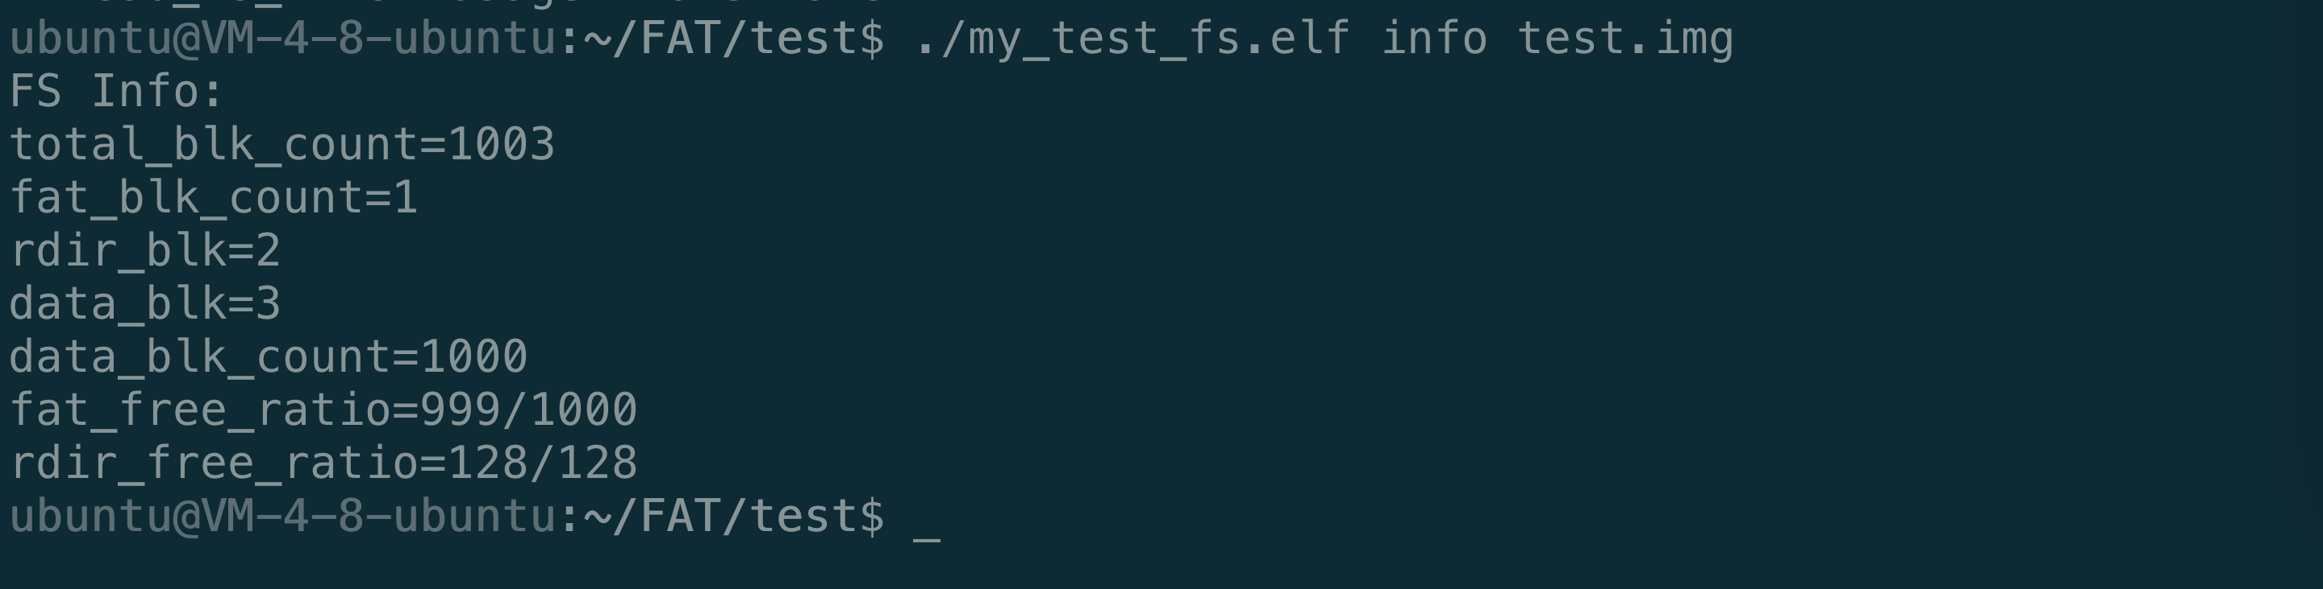

### 创建测试文件并写入硬盘

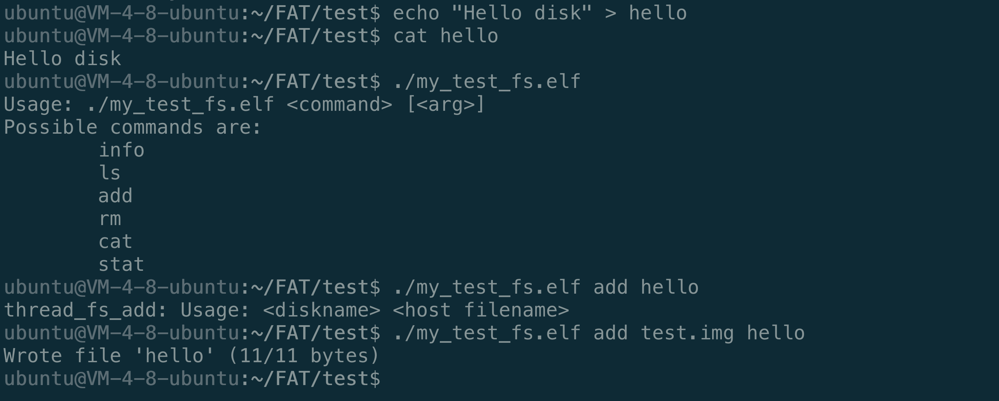

### 查看保存的文件

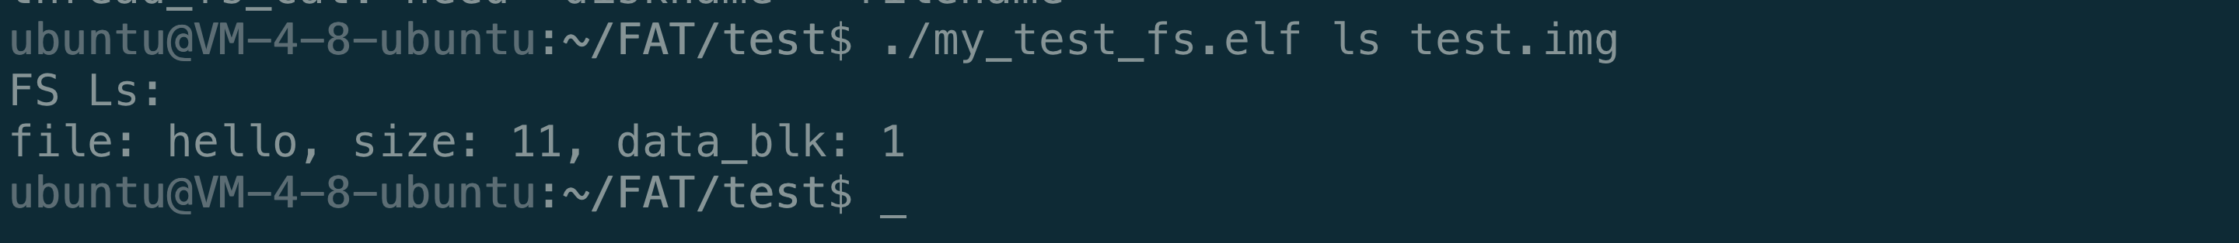

### 删除文件



### 检验

